
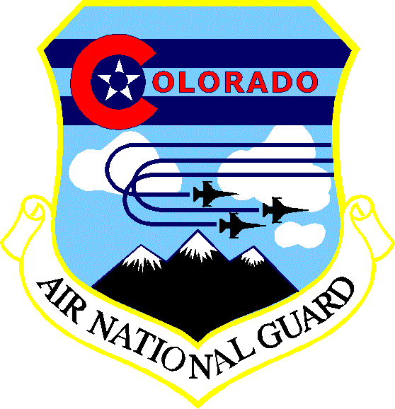
BUILDING BRIDGES
A cultural communiqué about our host country
By CMS Leo Lesh - Your State Human Resource Advisor

Saudi Arabia
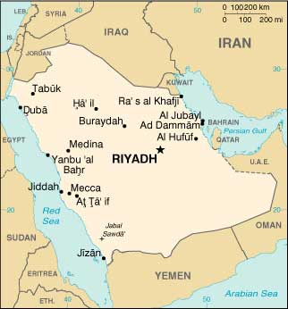
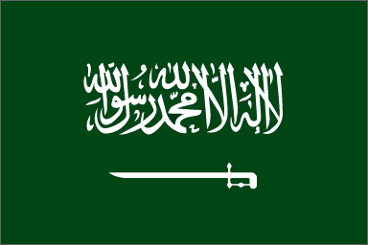

The flag of Saudi Arabia bears the Muslim creed:
"There is no god but God: Muhammad is the Messenger of God."

The Kingdom of Saudi Arabia comprises almost four-fifths of the Arabian Peninsula, an area approximately one-third the size of the continental United States. Geographically, it is situated in the southwestern part of Asia. The eastern part of Saudi Arabia is a plateau that begins with the great Nafud desert in the north, continues along the Arabian Gulf and culminates in the world's largest sand desert, the Rub Al-Khali (Empty Quarter), in the south. To the west of this plateau is the Najd, the heartland of the peninsula, known for its spectacular escarpments and gravel and sand deserts. The capital city of Riyadh is located in Najd. A chain of mountains in western Saudi Arabia runs parallel to the Red Sea. The Hijaz region along the Red Sea contains the holy cities of Makkah and Madinah, the port city of Jeddah and the summer

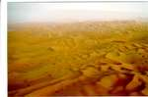
HISTORY; The Middle East, of which Saudi Arabia is an integral part, is the birthplace of civilization. It is in this area that man first settled in farming communities, developed agriculture, domesticated livestock, perfected trade and invented writing, setting the stage for the rise of civilizations such as Babylon, Nineveh, Phoenicia and Egypt. On its perimeter, and at a later stage, other great civilizations, such as Greece and Rome, would flourish. benefiting from the social and economic systems pioneered by the people of the region. The inhabitants of the Arabian Peninsula developed a civilization of their own that defied outside conquest. They interacted economically and culturally. trading with communities in the Fertile Crescent, which
stretches from what is present-day
Iraq through Syria to Turkey, as well as with Egypt, the Roman
Empire and other peoples beyond their immediate area. Cities along
the western and northern edge of the Arabian Peninsula were located
on a major overland trade route. Evidence of extensive commercial
trade dating from 3,000 B.C. has been discovered along this route.
Early trade commodities included agricultural products, spices, textiles
gold and frankincense.
In the early 18th century, Sheikh Muhammad Bin
Abdul Wahhab, the son of a religious judge, called on Muslims to
return to the original form of Islam. Initially persecuted, he later found
protection in the town of Diriyah, which was ruled by Muhammad
Bin Saud, a member of the prominent Al-Saud family. The partnership between these two men eventually led to the foundation of Saudi Arabia. Twenty-one-year-old Abdul Aziz Bin Abdul Rahman Al-Saud left Kuwait in 1901, determined to recapture all of the territory once held by his forefathers and to extend his protection over the holy cities of Makkah and Madinah. In a daring battle he recaptured Riyadh in 1902. This event marks the beginning of the formation of the modern state of Saudi Arabia. After establishing Riyadh as his headquarters, Abdul Aziz proceeded, over the following decades, to unite the different regions into one nation. On September 23, 1932, the country was named the Kingdom of Saudi Arabia as an Islamic state, with Arabic designated as the national language and the Holy Qur'an as its constitution.
CULTURE: As is commonly known, Arabia's culture derives from writings of the Holy Book. The richness of its language is without comparison and it is the fountainhead of Arabia's culture and faith. One direct manifestation of this heritage is the art of calligraphy of all Arabic art forms of this artistic expression. Craftsmanship of a high order is evident in the beautiful workmanship in precious metals. The ancient Arab tradition of hospitality continues unchanged to the present day.
The interlinking spheres of mathematics and astronomy are equally important aspects of the Arabian culture heritage. The word "algebra" is derived from Arabic word "Algebra". Navigation and cartography were direct developments of these numerate skills.

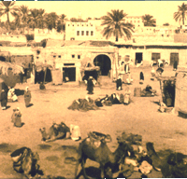
Similar attributes of outstanding craftsmanship are shown in the development of intricate workmanship in precious metals and even in household goods. It was in the settled communities such as Jeddah, Makkah that these skills flourished.

Both town dwellers and Bedouins, however, shared one ancient
Arab tradition: That of hospitality. Even today, in the home, or
on Saudi flight, drinking Arab coffee. The method of preparation
is traditional, each step is an almost ritually observed process.

The poetic tradition of the Bedouin is a further example of complex
and beautiful art form. Poetry promulgated the virtues and merits of
their tribes such as the obligation to respect social values. Generosity,
hospitality and courage were, to them, a matter of honor and failure
to adhere to this unwritten code was regarded as a great insult.

Despite the great pace of growth the Kingdom has witnessed over
the last two decades, traditional culture and social values have been
maintained steadfastly and the rich heritage of the Kingdom protected
and enhanced.

The strict observance of religious and moral values adopted by all Saudis will ensure that the continuity of their cultural heritage will not be diminished in the future.
CUSTOMS REGULATIONS: Saudi customs authorities enforce strict regulations concerning importation into Saudi Arabia of such banned items as alcohol products, weapons and any item that is held to be contrary to the tenets of Islam. This includes non-Islamic religious materials, pork products, and pornography. Saudi customs and postal officials broadly define what is contrary to Islam, and therefore prohibited. Christmas decorations, fashion magazines, and "suggestive" videos may be confiscated and the owner subject to penalties and fines. It is advisable to contact the Embassy of Saudi Arabia in Washington or one of Saudi Arabia's consulates in the United States for specific information regarding customs requirements.
SAUDI CUSTOMS, RELIGIOUS POLICE AND GENERAL STANDARDS OF CONDUCT: Islam pervades all aspects of life in Saudi Arabia. It is the official religion of the country, and public observance of any other religion is forbidden. Public non-Muslim religious services are illegal, and public display of non-Islamic religious articles such as crosses and Bibles is not permitted. Travel to Makkah (Mecca) and Medina, the cities where the two holiest mosques of Islam are located, is forbidden to non-Muslims.
The norms for public behavior in Saudi Arabia are extremely conservative, and religious police, known as Mutawwa, are charged with enforcing these standards. Mutawwa are required to carry special identification and usually are accompanied by uniformed police. However, in some cases they have detained persons even without police presence. To ensure that conservative standards of conduct are observed, the Saudi religious police have accosted or arrested foreigners, including U.S. citizens, for improper dress or other infractions, such as consumption of alcohol or association by a female with a male to whom she is not related. While most incidents have resulted only in inconvenience or embarrassment, the potential exists for an individual to be physically harmed or deported. U.S. citizens who are involved in an incident with the Mutawwa should report the incident to the U.S. Embassy in Riyadh or the U.S. Consulates General in Jeddah or Dhahran.
The Saudi Embassy in Washington advises women traveling to Saudi Arabia to dress in a conservative fashion, wearing ankle-length dresses with long sleeves, and not to wear trousers in public. In many areas of Saudi Arabia, particularly Riyadh and the central part of the Kingdom, Mutawwa pressure women to wear a full-length black covering known as an Abaya and to cover their heads. Most women in these areas therefore wear an Abaya and carry a headscarf to avoid being accosted. Women who appear to be of Arab or Asian origin, especially those presumed to be Muslims, face a greater risk of being confronted.
Some Mutawwa try to enforce the rule that men and women who are beyond childhood years may not mingle in public, unless they are family or close relatives. Mutawwa may ask to see proof that a couple is married or related. Women who are arrested for socializing with a man who is not a relative may be charged with prostitution. Some restaurants, particularly fast-food outlets, have refused to serve women who are not accompanied by a close male relative. In addition, many restaurants no longer have a "family section" in which women are permitted to eat. These restrictions are not always posted, and in some cases women violating this policy have been arrested. This is more common in Riyadh and the more conservative central Nejd region. Women are not allowed to drive vehicles or ride bicycles on public roads. In public, dancing, music and movies are forbidden. Pornography, which is very broadly defined by Saudi authorities, is strictly forbidden.
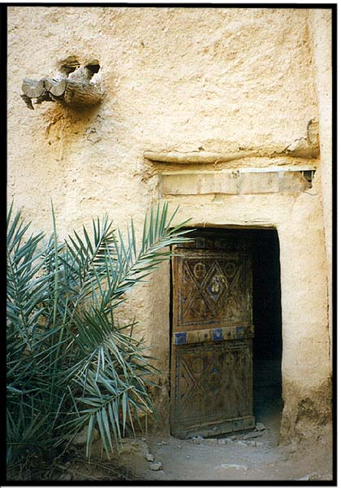
We strongly encourage all American citizens visiting or resident in
Saudi Arabia to maintain a high level of vigilance and take
appropriate steps to increase their security awareness and reduce
their vulnerability. Americans should maintain a low profile,
vary routes and times for all required travel, and treat mail and
packages from unfamiliar sources with suspicion. In addition,
American citizens are urged to avoid contact with any suspicious,
unfamiliar objects, and to report the presence of such objects to
local authorities. Vehicles should not be left unattended, if at all
possible, and should be kept locked at all times. American citizens
are urged to park their motor vehicles in protected areas with
restricted access and to inspect the vehicles before using them, looking
underneath, inside the engine compartment, and inside the trunk. The
use of a flashlight for vehicle inspections at night is recommended.
Suspicious activities, individuals, or vehicles should be reported to the
U.S. Embassy or nearest Consulate General. License numbers of
vehicles and descriptions of individuals are extremely helpful.
Saudi officials continue to cooperate closely with the Embassy to
ensure the safety of all Americans.

CLIMATE: Saudi Arabia has a hot and dry climate with frost
and freezing temperatures in winter while the Red Sea coast
experiences high humidity and temperatures. Rainfall is sparse
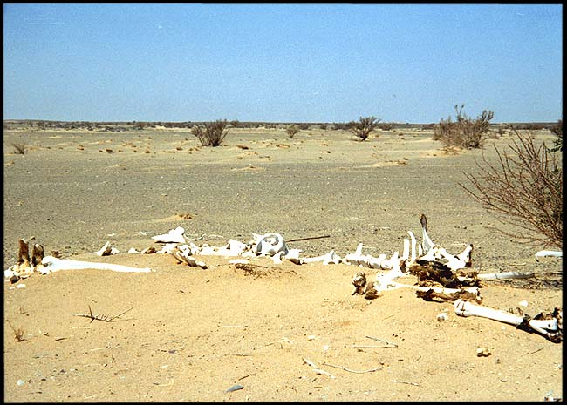
with an average annual precipitation of approximately 100 mm
(4 inches). The prevailing winds are severe dust storms such
as the southerly Kauf and the northwesterly Shamal. Average
temperature ranges in Riyadh are from 8 to 21 degrees Celsius
(46 to 70 degrees Fahrenheit) in January to 26 to 42 degrees
Celsius (79 to 108 degrees Fahrenheit) in July.
.
CRIMINAL PENALTIES: While in a foreign country, a U.S.
citizen is subject to that country's laws and regulations, which
sometimes differ significantly from those in the United States
and may not afford the protections available to the individual
under U.S. law. Penalties for breaking the law can be more severe
than in the United States for similar offenses. Persons violating
Saudi Arabia's laws, even unknowingly, may be expelled, arrested, imprisoned or even executed. Suspects can be detained, without charges or legal counsel and with limited consular access, for months during the investigative stage of criminal cases. As stated in Section 5 (CRIME), witnesses to possible criminal incidents also can be detained under similar circumstances for long periods of time. Even when released from detention, witnesses to criminal incidents may be prohibited from leaving the country until investigation of the incident is complete.
Besides alcohol products and illicit drugs, Saudi Arabia also prohibits the import, use, or possession of any item that is held to be contrary to the tenets of Islam (see "Customs Regulations" section above.) The private ownership of weapons is prohibited. Imported and domestic audiovisual media and reading matter are censored.
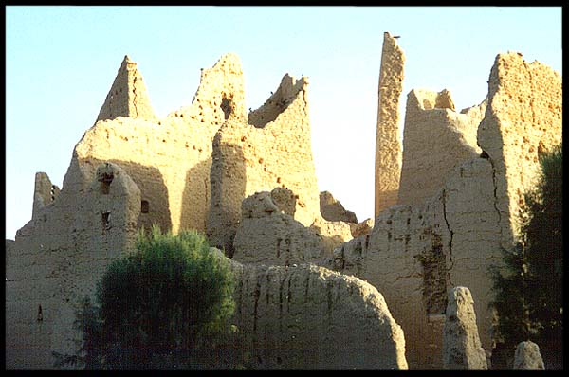
Saudi authorities do not permit criticism of Islam or the royal family. The government prohibits the public practice of religions other than Islam, although private worship by non-Muslims generally is permitted. Non-Muslims suspected of violating these restrictions have been jailed.
GOVERNMENT: Saudi Arabia is a monarchy headed by
King Fahd Bin Abdul Aziz,
Custodian of the Two Holy Mosques and Head of State.
Assisting him in his duties areCrown Prince Abdullah Bin Abdul Aziz
is the Deputy Prime Minister of Saudi Arabia and Commander
of its National Guard.
Prince Sultan Bin Abdul Aziz is the Second Deputy Prime Minister,
Minister of Defense and Aviation, and Inspector General.
and other ministers appointed to the Council of Ministers, which meets
every Monday except during the two major holidays.
King Fahd has taken historic steps to revise the Kingdom’s political
and administrative system. On March 1, 1992, he introduced a new
Basic Law for the System of Government which outlined the
government’s goals and responsibilities and redefined the relationship
between the King and his citizens. In addition, for the first time, the
rules of succession to become Head of State were put into writing
and formalized. New bylaws were also introduced for the Council
of Ministers.
Ministers are appointed by the King and are responsible for implementing governmental policies which relate to their particular ministry. The Council of Ministers, headed by the King, is responsible for drafting and overseeing implementation of the internal, external, economic, financial, social, educational, defense, and other general matters of the state.
LOCAL GOVERNMENT: In 1993, King Fahd also promulgated new bylaws for the Provincial System to aid in the administration of the country’s provinces and to facilitate their continued development. The Kingdom is divided into 14 provinces through which local affairs are administered. Each is headed by an Emir (governor) who is appointed by the King. The governor is assisted by a vice governor. He is also assisted by a provincial council, which is composed of the heads of the province’s government departments and a ten-member council of prominent individuals in the community who are appointed to four-year, renewable terms.
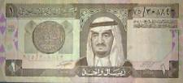
SHOURA COUNCIL: In August 1993, King Fahd restructured the Majlis Al-Shura (national consultative council) to make it more efficient. The Majlis Al-Shura, which was initially composed of 60 prominent members of Saudi social, political, and religious life, was expanded to 90 members in 1997. The Majlis Al-Shura advises the King and the Council of Ministers on a regular basis on matters pertaining to government programs and policies. The Shura Council’s primary function is to assess, interpret, and modify the Kingdom’s system of laws, by-laws, contracts, and international agreements.
CURRENCY: The official currency is the Riyal (SRls) divided
into 5 Qurushes and 100 Halalahs Saudi coins are called halalahs.
Coinage denominations are 5, 10, 25, 50 and 100 halalahs with
100 halalahs equal to one riyal. Bank notes, printed in Arabic on
one side and English on the reverse, are in denominations of
1, 5, 10, 50, 100 and 500 riyals. One U.S. dollar is equivalent
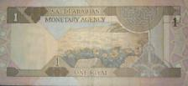
o 3.745 Saudi riyals.

ISLAM HISTORY: Islam, one of the world's great monotheistic
religions, has Saudi Arabia as its heartland. The followers of Islam,
called Muslims, believe in God, -- in Arabic, Allah -- and that
Muhammad is His Prophet. Today, the worldwide community of
Muslims, which embraces the people of many races and cultures,
numbers approximately one billion. Historically, Saudi Arabia has
occupied a special place in the Islamic world, for it is towards
Makkah and Islam's most sacred shrine, the Ka'abah, located in the Holy Mosque there, that Muslims throughout the world turn devoutly in prayer five times a day. An appreciation of Islamic history and culture is therefore essential for a genuine understanding of the Kingdom of Saudi Arabia, its Islamic heritage and its leading role
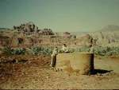
in the Arab and Muslim worlds.

THE FIVE PILARS OF ISLAM: They are the framework
of the Muslim life: faith, prayer, concern for the needy, self-
purification, and the pilgrimage to Makkah for those who are able.

Faith There is no go worthy worship except God and Muhammad
is His messenger. The declaration of faith is called the Shahada,
a simple formula which all the faithful pronounce. In Arabic,
the first part is la ilaha illa'Llah- 'there is no god except God';
Ilaha (god) can refer to anything which we may be tempted to
put in place of God- wealth, power, and the like. Then comes
illa'Llah: 'except God', the source of all Creation. The second
part of the Shahada is Muhammadun rasulu'Llah: 'Muhammad
is the messenger of God.' A message of guidance has come through
a man like ourselves

Prayer alat is the name for the obligatory prayers which are performed five times a day, and are direct link between the worshipper and God. There is no hierarchical authority in Islam, and no priests, so the prayers are led by a learned person who knows the Quran, chosen by the congregation. These five prayers contain verses from the Quran, and are said in Arabic, the language of the Revelation, but personal supplication can be offered in one's own language.
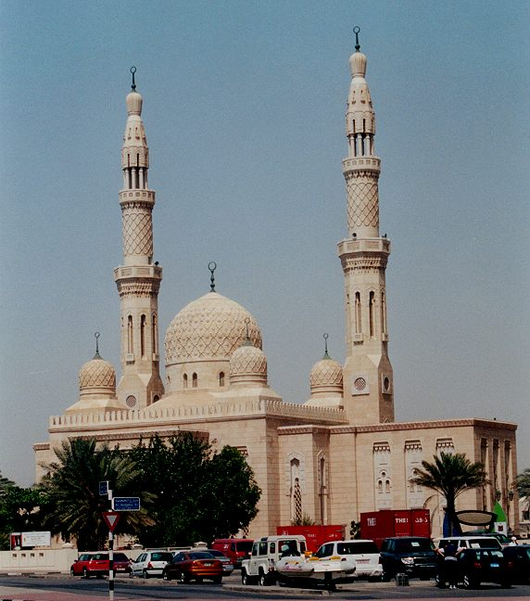
Prayers are said at dawn, noon, mid-afternoon, sunset and nightfall, and thus determine the rhythm of the entire day. Although it is preferable to worship together in a mosque, a Muslim may pray almost anywhere, such as in fields, offices, factories and universities.

The Zakat One of the most important principles of Islam
is that all things belong to God, and that wealth is therefore
held by human beings in trust. The word zakat means both '
purification' and 'growth'. Our possessions are purified by
setting aside a portion for those in need, and, like the pruning
of plants, this cutting back balances and encourages new growth.
Each year Muslim calculates his or her own zakat individually.
For most purposes this involves payment each year of two and
a half percent of one's capital. A pious person may also give as much
as he or she pleases as sadaqa, and does so preferably in secret. The
Prophet (PBUH) said: 'even meeting
your brother with a cheerful face is charity.

The Fast Every year in the month of Ramadan, all Muslims fast
from first light until sundown, abstaining from food, drink, and
sexual relations. Those who are sick, elderly, or on a journey, and
women who are pregnant or nursing are permitted to break the fast
and make up an equal number of days later in the year. If they are
physically unable to do this, they must feed a needy person for every
daymissed. Children begin to fast (and to observe the prayer) from
puberty, although many start earlier. Although the fast is most
beneficial to the health it is regarded principally as a method of
self-purification. By cutting oneself off from worldly comforts, even for a short time, a fasting person gains true sympathy with those who go hungry as well as growth in one's spiritual life.

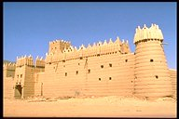
The Pilgrimage (Hajj) The annual pilgrimage to Makkah- the Hajj- is an obligation only for those who are physically and financially able to perform it. Nevertheless, about two million people go to Makkah each year from every corner of the globe providing a unique opportunity for those of different nations to meet one another. Hajj begins in the twelfth month of the Islamic year (which is lunar, not solar, so that Hajj and Ramadan fall sometimes in summer, sometimes in winter). Pilgrims wear special clothes: simple garments which strip away distinctions of class and culture, so that all stand equal before God.

LANGUAGE: Arabic Language is one of the Semitic groups
of languages, one of the oldest groups of languages in the world.
The precise origins of the Arabic language are unknown but it is
certain that the inhabitants of the Arabian Peninsula were the first
to use it in pre-Islamic times. With the expansion of Islam and
Islamic culture in the 7th century AD, the Arabic language spread
north, east and west. The Arabic language is today one of the
world's most widely spoken languages. There are some 200 million
Arabic speakers in more than 20 countries. Arabic is the official
language of many Arab nations in the Middle East and northern
Africa.

Written (Classical) Arabic serves as the standard written language
of all Arab nations. It is the language of the Holy Quran, the sacred
book of the Islam, and has changed little over the centuries. Arabs
use a spoken form of written Arabic for formal speech, radio and TV news broadcasts and in films, plays and poetry. This form also serves as a common spoken language for Arabs from all parts of the Arabic-speaking world who have their own dialects for every day speech.
The easy group of Arabic letters:
A- is similar to the a in bag. K- similar to the English k
u- is similar to the u in Bulgaria I- similar to the English I
i - is similar to the i in Sit m- similar to the English m
ậ- this is a “long a” similar to the a in Father n- similar to the English n
û - this sounds like “o” as in Swoon y similar to the English y in Yes
î - like a long I w- similar to the English w
b- similar to the English b MORE difficult Letters
t- similar to the English t q- a type of k sound, but deep in the throat
th- when next to one another it sounds like th in Think kh- similar to ch as in Bach
sh- when next to one another it sounds like sh in Shilling c- no similarity, a sound which starts deep in the throat
dh- when next to one another it sounds like th in That ' but works as a pause in a word
r- rolled r like Road h- stressed h, but a pure English h
d- similar to English d d- stressed d, and when followed by a, the a is as in car
s- similar to English s s- stressed s, and when followed by a, the a is as in car
f- similar to English f t- stressed t, and when followed by a, the a is as in car
h- similar to English h z- stressed z, and when followed by a, the a is as in car

COMMON PHRASES: Arabic
marhaban 'as-salâmu ^{c}alaykum ^{c}alaykumu s-salâm
Hello; welcome Hello; Peace upon you Hello; Peace upon you, too
Shukran 'anâ bi-khayr ma^{c}a salâma
Thank you I'm fine Go without fear
ilâ l-liqâ' mâ-smuk? 'ismî
So long; Until the next time What's your name? My name is
'ismuhu 'ismuhâ 'anâ sâ'ih
His name is Her name is I'm a tourist (as uttered by a man)
'anâ sâ'iha 'a^{c}mal hunâ 'anâ tâlib
I'm a tourist (as uttered by a woman) I'm working here I'm a student (as uttered by a man)
'anâ tâliba masâ'a l-khayr hal tatakallumu l-inkliziyya?
I'm a student (as uttered by a woman) Good evening Do you speak English?
Hal talfham 'anâ laAfham assayed asseyedah/alanessah
Do you understand I do not understand Mr. Mrs./Miss
Min fadlik kaiga-hâluk sâ edny
Please/Thank you How are you Help
wa kûkâ kûlâ wa qanînatu l-mâ' na'am / la
And a Coca Cola And a bottle of water yes / no

NUMBERS: Arabic
O 1 2 3 4 5 6
sifr wâhid ithnân thalâtha 'arba^{c}a khamsa sitta

7 8 9 10 11 12 13
sab^{c}a thamâniya tis^{c}a ^{c}ashra khamsa ^{c}ashra ithnâ ^{c}ashra thalâtha ^{c}ashra

14 15 16 17 18 19 20
'arba^{c}a ^{c}ashra khamsa ^{c}ashra sitta ^{c}ashra sab^{c}a ^{c}ashra thamâniya ^{c}ashra tis^{c}a ^{c}ashra ^{c}ishrûn

22 25 30 40 50 60 66
ithnân wa-^{c}ishrûn khamsa wa-^{c}ishrûn thalâthûn 'arba^{c}ûn khamsûn sittûn sitta wa-sittûn

70 - sab^{c}ûn 80 - thamânûn 84 - 'arba^{c}a wa-thamânûn 90 - tis^{c}ûn 91- 'ahad wa-tis^{c}ûn 100 - mi'a

SOURCES: SAUDI ARABIA INFORMATION RESOURCE; CIA WORLD FACTBOOK; BRIEF HISTORY OF SAUDI ARABIA;
ARABIA.NET – SAUDI ARABIA

SAUDIA ARABIA AIR FORCE

 |  | 
JUNDI AWWAL | ARIF | WAKIL RAQIB
Airman 1st Class | Senior Airman | Staff Sergeant

 |  | 
NAIB RAQIB | RAQIB | RAQIB AWWAL
Technical Sergeant | Master Sergeant | Senior Master Sergeant

 |  |  | 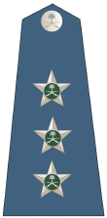
RA´IS RUQUBA | MULAZIM | MULAZIM AWWAL | NAQIB
Warrant Officer | 2nd Lieutenant | 1st Lieutenant | Captain

SAUDIA ARABIA AIR FORCE
 |  |  | 
RAID | MUQADDAM | AQID | AMID
Major | Lieutenant Colonel | Colonel | Brigadier General

 |  | 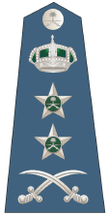
LIWA | FARIQ | FARIQ AWWAL
Major General | Lieutenant General | General

SOURCE: WORLD RANK INSIGNIA

